**7. Configure a management VLAN and assign an IP address for remote access. Test SSH or Telnet access to the switch.**

* Created VLAN 10 for management
* Assigned an IP address to VLAN 10 (192.168.1.1/24)
* Assigned a port (Fa0/1) to VLAN 10
* Configured SSH and Telnet
* Set up a PC with an IP (192.168.1.2/24) for testing
* Tested remote access using ping, ssh, and telnet

**Setting Up:**

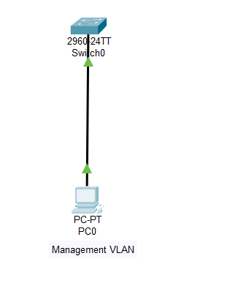

**SSH and TELNET configuration:**

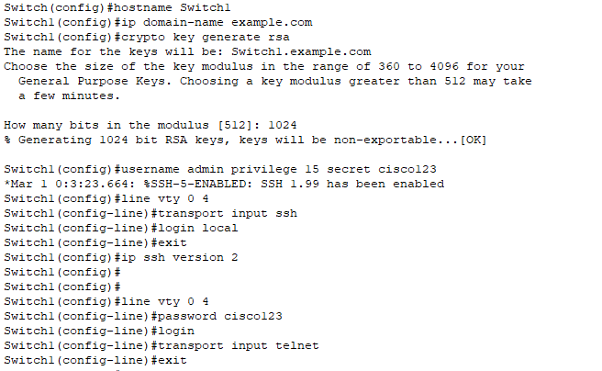

**TELNET Access:**

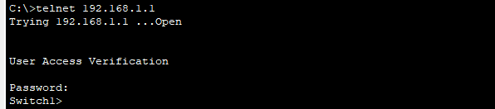

**SSH Access:**

